

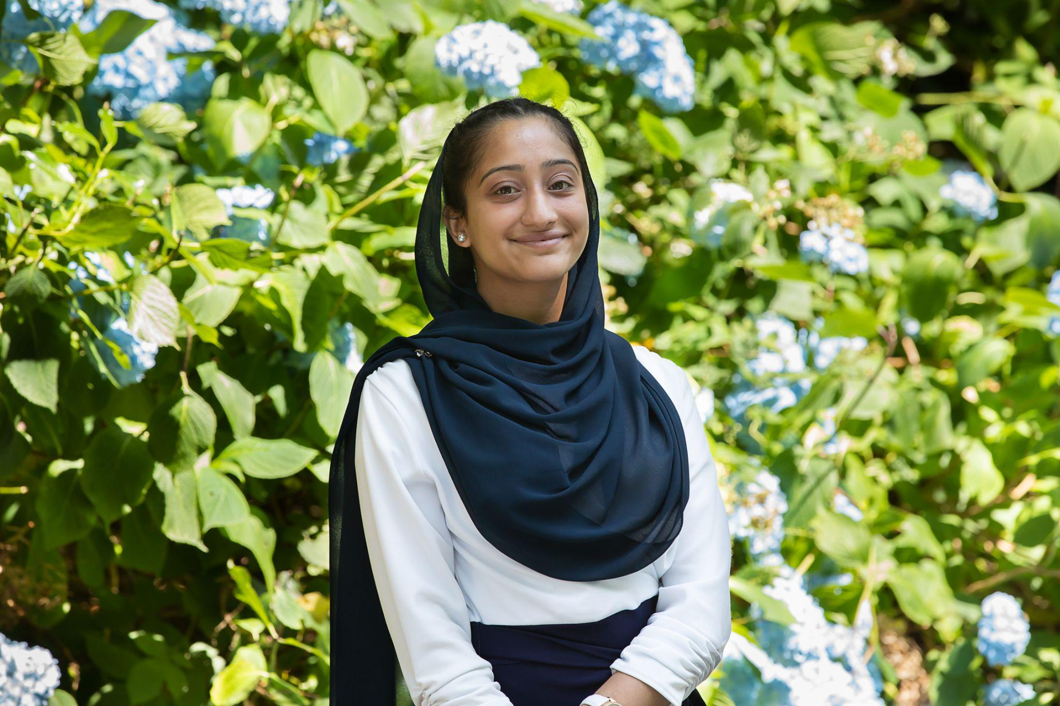

**Who am I?**

I’m Ayesha Dar, and I’m a Project Control degree apprentice working in the Aerospace and defence industry. My work involves reporting and managing project budgets, schedules, risks, performance metrics, adherence to governance and key stakeholders. I enjoy long walks, eating out with friends, and a good book!

**Why did I become a Hillside Governor?**

It’s a huge passion of mine to give back to the community that helped me to grow and thrive as a person. My aim is to use the skills I’ve developed as a project controller to provide advice and support the strategic direction of the school. Hillside is particularly special - as a governor my eyes have been opened to the dedicated teachers and compassionate staff that work incredibly hard to create a nurturing environment for the children at Hillside to thrive.

**What do I bring to the governing body?**

Adherence to the core functions established by the DfE as a governor, including being accountable for decision being taken, scrutiny of key decision-making and school performance, and assurance that hillside is operating efficiently and compliantly. I hope to support and contribute to this inclusive educational environment as a governor, with a focus to careers and DEI, particularly as I have only recently left the education system.